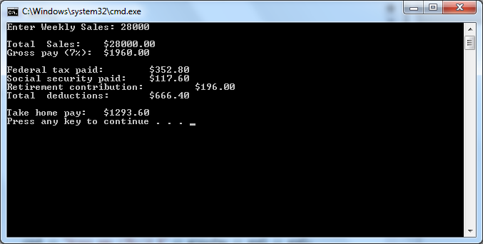

// ---------------------------------------------------------------

// Developer: Kevin Nguyen

// Date Written: 5/9/15

// Purpose: Ticket Calculation Program

// ---------------------------------------------------------------

#include<iostream>

#include<iomanip>

usingnamespacestd;

void main()

{

doubleweeklySales, grossPay, fedTax, socSecurity, retirement, totDeductions, takeHomePay;

cout<<"Enter Weekly Sales: ";

cin>>weeklySales;

cout<<endl;

//use fixed and setprecision(2) to format the number

//use setw(8) to control the width of the field

//use \t to control the spacing between fields

cout<< fixed <<setprecision(2);

grossPay = weeklySales \* .07;

fedTax = grossPay \* .18;

socSecurity = grossPay \* .06;

retirement = grossPay \* .10;

totDeductions = fedTax + socSecurity + retirement;

takeHomePay = grossPay - totDeductions;

cout<<"Total Sales:\t $"<<weeklySales<<endl;

cout<<"Gross pay (7%):\t $"<<grossPay<<endl<<endl;

cout<<"Federal tax paid:\t $"<<fedTax<<endl;

cout<<"Social security paid:\t $"<<socSecurity<<endl;

cout<<"Retirement contribution:\t $"<< retirement <<endl;

cout<<"Total deductions:\t $"<<totDeductions<<endl<<endl;

cout<<"Take home pay:\t $"<<takeHomePay<<endl;

system("pause");

}